27th July 2020
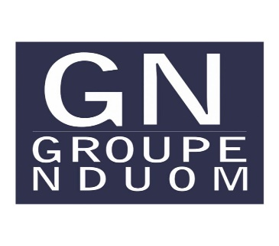

PRESS RELEASE
GN Bank Is NOT a Ponzi Scheme

The American President Theodore Roosevelt said:

“It is not the critic who counts; not the man who points out how the strong man stumbles, or where the doer of deeds could have done them better. The credit belongs to the man who is actually in the arena, whose face is marred by dust and sweat and blood; who strives valiantly; who errs, who comes short again and again, because there is no effort without error and shortcoming; but who does actually strive to do the deeds; who knows great enthusiasms, the great devotions; who spends himself in a worthy cause; who at the best knows in the end the triumph of high achievement, and who at the worst, if he fails, at least fails while daring greatly, so that his place shall never be with those cold and timid souls who neither know victory nor defeat.
GN Bank did not achieve 300 retail outlets and over one million customers by being a Ponzi scheme. It did not sprout up overnight. It did not benefit from government contracts or fund-raising schemes. Its license was not gifted to the shareholders or directors. The Bank was developed from hard work and sacrifice.
“Speaking in an interview on Accra based, Asaase Radio on Sunday, July 26, the Minister of Finance Ken Ofori-Atta is alleged to have said; “When we got into office in January 2017, one of the documents that were called the Assets Quality Review of the banks showed most of these banks were literally bankrupt and therefore they were ‘ponzi schemes’ taking people’s money, loaning them to people and just regenerating them.””
For the avoidance of doubt, GN Bank can never be said to be one of those banks referred to by the Minister.
In 1997, a company was registered called First National Savings and Loans Company Limited. After nine years of planning, preparation and interactions with the Bank of Ghana (BOG), First National Savings & Loans Company Limited was granted a license to open for business in May of 2006. A number of local companies and people were rejected as potential shareholders. Eventually, our company, Coconut Grove Hotels became the major shareholder, later to be joined by others. The required Capital was paid in and verified by the BOG.
The huge investment of funds, energy and sweat was paid for by shareholders and was completed in July 2018. At our peak, we employed over 2,000 people, mostly very young men and women. Together with security guards and other service providers, our numbers exceeded 3,000. We made it possible for small businesses in places such as Widana, Djemeni, Kwame Danso, Walewale, Pusiga, Tumu, Paga, Debiso, Tuobodom, Anloga and many, many other towns other licensed financial institutions wouldn’t go.
In the case of GN Bank, it is the crisis in the financial system hit in August of 2018 that created a liquidity challenge. Prior to that, we were a very, highly liquid bank with a low non-performing loan portfolio. Our customers were happy with GN Bank.
Indeed, the results of diagnostic studies commissioned by the Bank of Ghana (BOG) in 2015 prove us right. The results were reviewed by BOG Supervision Department officials and confirmed during the first quarter of 2016. BOG wrote to GN Bank that the results of the study showed that “...your bank was assessed to hold adequate provision for your financial exposures.” The diagnostic study into the loans and investments of banks in the case of GN Bank was performed by the international accounting firm Ernst & Young.
GN CORPORATE AFFAIRS

