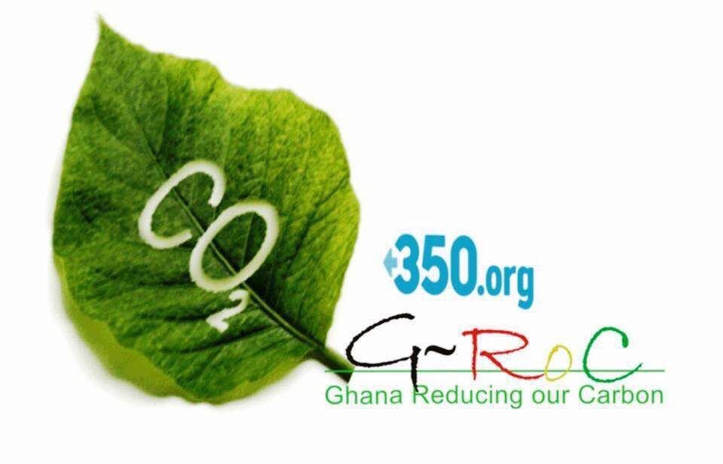PRESS RELEASE
350 -GROC Ghana CONGRATULATES MR. CHIBEZE EZEKIEL FOR WINNING THE GOLDMAN PRIZE
350 Ghana Reducing our Carbon expresses it's warmest congratulations to Mr. Chibeze Ezekiel, board member of 350 org. , the Co coordinator of 350 GROC on winning the Goldman Environmental Prize for the year 2020 in the African Category.
The Goldman Environmental Prize "honors grassroots environmental heroes from roughly the world's six inhabited continental regions: Africa, Asia, Europe, Islands & Island Nations, North America, and South & Central America. The Prize recognizes individuals for sustained and significant efforts to protect and enhance the natural environment, often at great personal risk while inspiring all of us to take action to protect our planet"
For years, Africa's youth have been calling for climate justice that would see a transition from fossil fuels and building climate resilient economies powered by renewables. This is exactly what Chibeze, 350 G-ROC and our CSO partners have been fighting for. As a climate leader, Chibeze has shone a spotlight on the climate crisis while helping his country, Ghana to think of a socially and environmentally just, zero-carbon future. Chibeze has been a strong voice of the youth and grassroots groups. The recognition of his and other allies' work shows that collective efforts through community organizing and campaigning can empower ordinary people to demand their rights and overcome social injustices and achieve inspiring wins for thousands of grassroots activists.
Chibeze having been honored by the prize for leading our prestigious movement in the anti-coal campaign journey against plans for the government of Ghana to establish a coal-powered plant in Ekumfi in the Central Region has given the team energy to continue fighting for our next generation.
We wish to use this opportunity to thank all our local partners and mother organizations who helped to make this a success. The cause is still on, and we as 350 GROC will still be steadfast in urging the government of Ghana to be more ambitious as climate leaders and at least ensure 30% Renewable Energy as an energy sources in the Energy Mix by the year 2030.
The youth of Ghana are counting on the Government for a renewable energy future and we will work tirelessly to get there.And a recognition of this magnitude is proof of the amount of resilience, drive and ambition we have.
Thank you.
Portia Adu-Mensah
National coordinator
350GROC

