AMALGAMATED MUTUAL FUND PLC BEGINS PARTIAL BAILOUT PAYMENTS TO CLIENTS OF FUND MANAGEMENT COMPANIES WHOSE LICENSES HAVE BEEN REVOKED

ACCRA – 04 December, 2020: The Amalgamated Mutual Fund PLC (The AM Fund) has commenced cash payments under the partial bailout scheme to clients of the Fund Management Companies (FMCs) for which the Official Liquidator has yet to obtain Liquidation Orders from the courts.

This follows the announcement by the Securities and Exchange Commission (SEC) on 18th November, 2020, that Government has authorized a partial bailout involving payments of up to GHS50,000 each, to customers of FMCs whose licenses have been revoked but whose liquidation processes in the courts have not been concluded.

Affected clients are required to follow a simple 3-step process to access cash under the partial bailout scheme as follows:
- Accept the Offer
Clients are to accept the bailout package at www.bailout.rgd.gov.gh, as stated in the text message sent to them by SEC.
- Complete Onboarding/KYC
To verify identities and ensure funds are paid to the right persons via The AM Fund, clients are required to submit identification documents. Therefore, within 5 working days of accepting the offer, clients receive text messages from The AM Fund, requiring them to upload KYC documents (passport picture, ID document, address document, etc.) at www.gcbcapital.com.gh/bailout. Corporate entities are required to upload the usual corporate KYC documents.
- Collect Cash
Clients are sent text messages within 5 working days of completing onboarding that their monies have been paid into GCB Bank accounts opened for them. Clients can then go to any GCB Bank branch with copies of their onboarding documents for the accounts to be activated and the cash paid to them.

Please note: Cash payment to clients of the FMCs in full liquidation began on 8th October, 2020, and is continuing per prior arrangements.

GCB Capital is committed to ensuring smooth processing of payments for both the full bailout and partial bailout streams. Clients can make enquiries or obtain assistance by contacting us on 055 256 4472 or amfund@gcb.com.gh.
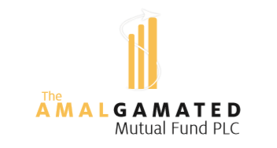 | 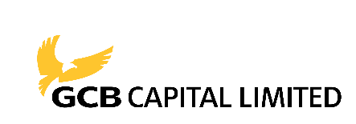  www.gcbcapital.com.gh/bailout

